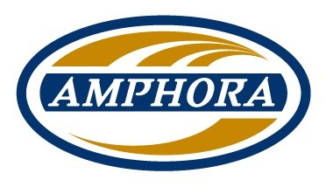

**BACK TO WORK PROGRAM**

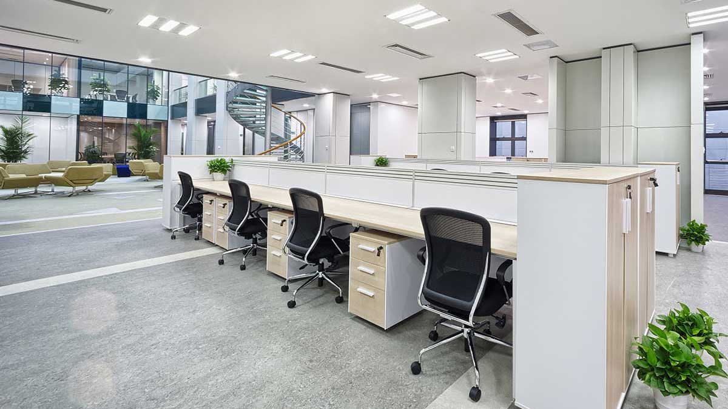

**CLEANING AND DISINFECTING**

**As part of our Back to Work Program, we are here to ensure that all tenants and persons entering our buildings feel safe and comfortable.**

**Amphora is using top grade cleaners and hospital grade disinfectants.**

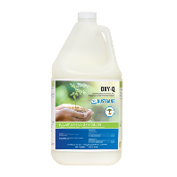Oxy-Q 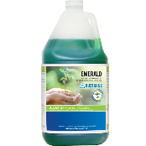 Emerald

**Hydrogen Peroxide Based Disinfectant Hard Surface Cleaner & Degreaser** **[Oxy-q Hydrogen Peroxide Based Disinfectant](https://www.dustbane.ca/products/oxy-q)** [**Emerald Hard Surface Cleaner and Degreaser**](https://www.dustbane.ca/products/emerald)

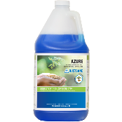Azure 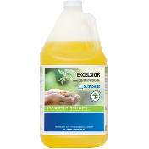Excelsior

**All Purpose Surface & Glass Cleaner General-Purpose Hard** **Surface Cleaner**

[**Azure Glass Cleaner**](https://www.dustbane.ca/products/azure)[**Excelsior General Purpose Hard Surface Cleaner**](https://www.dustbane.ca/products/excelsior)

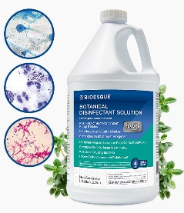 **EPA for use on hard non-porous surfaces against the SARS-CoV-2 virus** **(COVID-19) in just 55 seconds.**

<https://bioesquesolutions.com/botanical-disinfectant-solution/>

**All of the products that Amphora uses are safe and green and certified be the Canadian government.**

**BACK TO WORK EMPLOYEE PROCEDURES**

**Upon arrival all employees will be asked to wash their hands for 20 seconds or sanitize hands with an alcohol-based sanitizer. They will then meet with the supervisor in the maintenance room respecting social distancing of 2 meters. Only 2 employees will be able to enter the maintenance room at the same time. Employee breaks will be staggered to prevent and ensure safety.**

**Before every shift, the employees will be screened by a supervisor, which will go through a Covid-19 screening checklist and a temperature reading. The results of the screening test completed be the supervisor will determine weather the employee will or not. Each employee must meet the requirements necessary to be deemed fit to work.**

**Checklist**

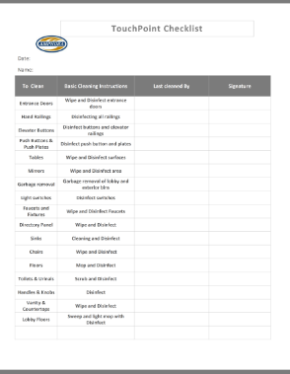

**All employees have entered and completed online seminars.**

**During working hours, employees will be in (PPE) and gloves at all times. Social distancing will be practiced and signs will be displayed as a reminder.**

**Social Distancing sign**



**During each employee’s shift, there will be very limited interaction with tenants and guests. Social distancing will always be respected at all times.**

**When employees finish their shift, all equipment will be disinfected** **and put away.**

**BACK TO WORK EMPLOYEE PROCEDURES PROTOCOL**

**If you experience any of the following please stay home and isolate yourself.**

* **Fever**
* **Coughing**
* **Runny nose**
* **Trouble breathing**

**Hygiene**

* **Wash your hands frequently with water and soap for at least 20 seconds following the (WHO) World Health Organization guidelines.**

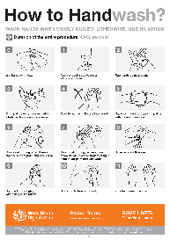

* **When entering workplace please clean your hands with an alcohol base sanitizer**
* **While at the workplace it is mandatory to wear PPE and gloves at all times.**
* **Only use your own supplies and equipment.**
* **Sanitize equipment when shift is over.**

**Safety and Social Distancing**

* **Always keep 2 meters away from everyone you encounter.**
* **There should never be more than 2 staff members in the maintenance room at any given time.**
* **Please keep at least 2 meters distance from your co-workers during breaks.**
* **No more than 2 people to an elevator at all times, remembering to keep your distance.**

**BACK TO WORK REOPENING**

**Amphora recommends that all areas are given a deep cleaning and disinfecting before all tenants return. Disinfecting of all high touch point surfaces, deep extraction of carpeted areas, tiled floors and washrooms.**

Oxy-Q 

**Hydrogen Peroxide Based Disinfectant Kills (COVID-19) in just 55 seconds**

[**Oxy-q Hydrogen Peroxide Based Disinfectant**](https://www.dustbane.ca/products/oxy-q)

**It is also recommended to increase the frequency and disinfecting of high touch points areas.**

**We offer additional services to help increase cleanliness and disinfecting of high touch point areas such as:**

* **All entrance Doors, Railings, Elevator Buttons, Lights Switches, Push Buttons (Hourly)**
* **Chairs, Tables, Countertops and Directory Panels.**
* **Washroom Knobs, Handles, Faucets, Doors and Partitions, Urinals and Toilets (Hourly)**
* **Tiled Floors and Washroom Tiles**

**[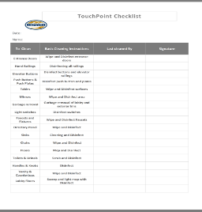](https://d.docs.live.net/40a1aeecd892684f/Documents/Amphora%20Touch%20Point%20Checklist_00.png) Amphora Touchpoint Checklist**

**All designated Disinfecting Team Members will be uniformed with Orange Shirts as to easily identify.**

**These services can be provided at an additional cost catered to you. (minimum of 4 hours).**

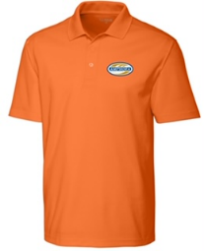

**EMERGENCY COVID-19 RESPONSE TEAM**

**As part of Amphora’s commitment to our clients, we have created Emergency Response Team dedicated to Covid-19 outbreaks. This service is offered 24 hrs-7 Days per week. All of our team members are equipped with full body PPE and gloves, disinfectants and equipment to service any and all needs.**

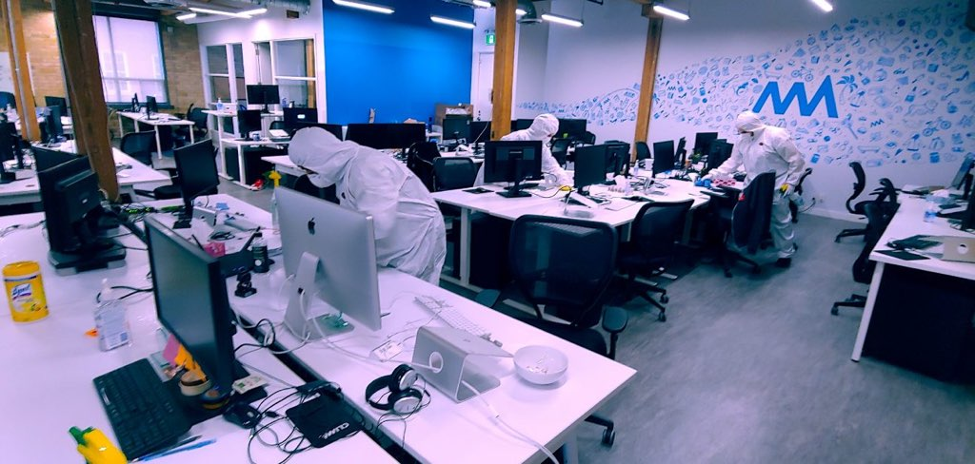

**When deployed our staff will disinfect all areas that have been exposed to the virus.**

**Emergency disinfecting cleaning of all contact areas:**

* **Tables, complete chairs, phones, keyboards, monitors**
* **Doors, handles, ledges, walls and all floor areas**
* **Washroom doors, partitions, faucets, toilets, urinals, mirrors and countertops**
* **All entry points and exit points to the exposed areas**

**Cleaning using Dry Mist FOG Sanitizer**

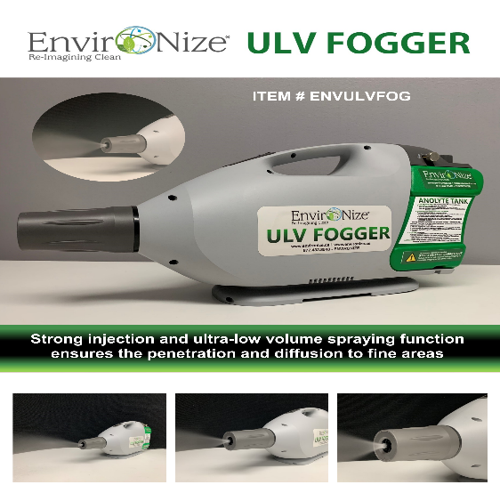

**Disinfection and Sterilization**

**The EnviroNize ULV Fogger enables injections / EnviroNize Anolyte 50 ULV/ Dry Mist FOG Sanitizer solution to every area of the targeted disinfection. Its small micron droplet nozzle that is adjustable, provides for complete coverage and protection against infectious pathogens which are killed in seconds.**

**The EnviroNize® Ultra ULV Fogger provides fast and efficient disinfection using a Hand-Held Corded Fogger. Goes way beyond your old fashion trigger sprayer allowing you to disinfect more area. Completely fog an entire room in less than 3~5 minutes. Deploys 10~15 micron Mist Disinfection Droplets. NO ESCAPING ⁃ Dust ⁃ Harmful Airborne Pathogens and Spores. Pathogens are attracted to the Ultra Dry Mist Fog like a magnet! Pathogen eradicating begins on contact with EnviroNize® Anolyte 50. EnviroNize.**

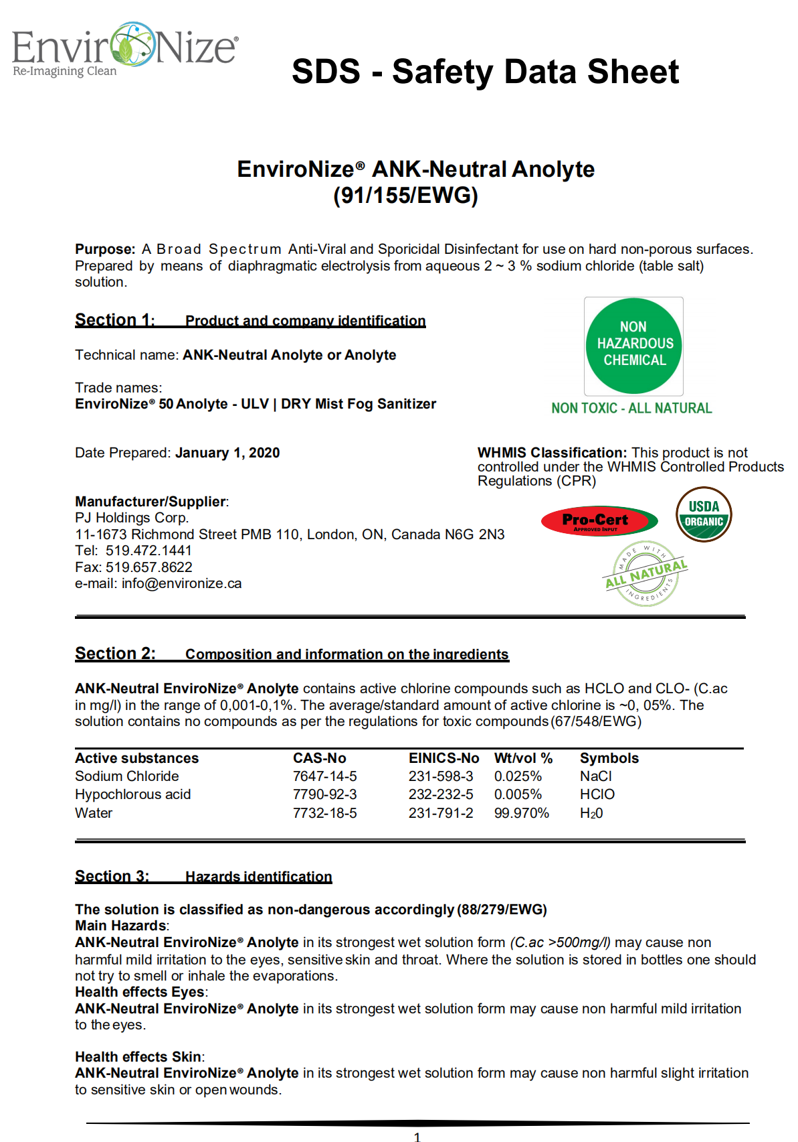

[**https://youtu.be/EGVCgE2jNxg**](https://youtu.be/EGVCgE2jNxg)[**https://youtu.be/c_0qFk_3naA**](https://youtu.be/c_0qFk_3naA)[**https://youtu.be/EtFm-StrpQY**](https://youtu.be/EtFm-StrpQY)

[**https://youtu.be/ItaGkqTyfEU**](https://youtu.be/ItaGkqTyfEU)

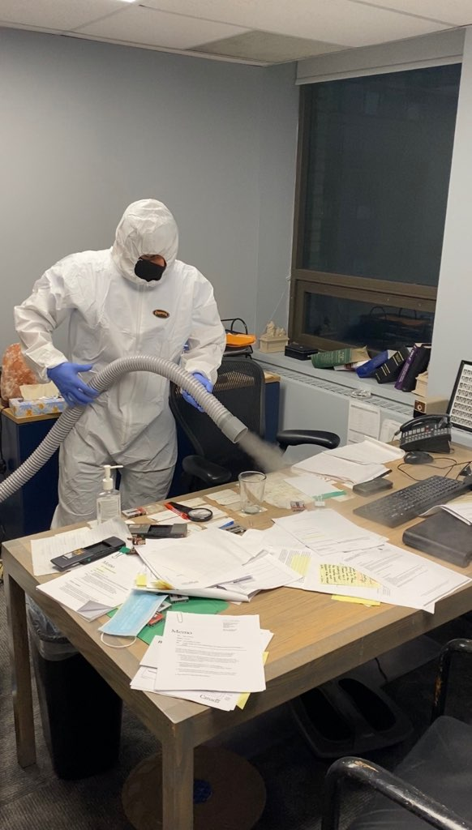 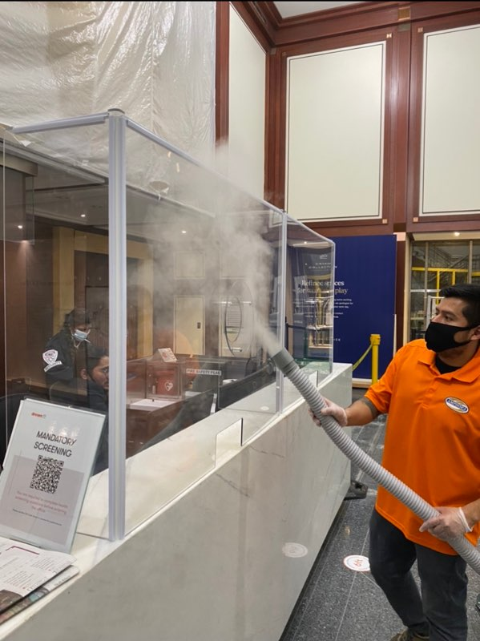

**We recommend the ULV Fogger for areas of concern:**

